* **What is SDLC**

**Answer**:- SDLC is a structure imposed on the development of a software product that defines the process for planning, implementation, testing, documentation, deployment, and ongoing maintenance and support.

* **What is software testing?**

**Answer**:- Software Testing is a process used to identify the correctness, completeness, and quality of developed computer software.

* **What is agile methodology?**

**Answer:- Agile methodology is an approach where testing is carried out continuously alongside development in small iterations or sprints. It helps in getting quick feedback, adapting to changes easily, and delivering high‑quality software faster.**

* **What is SRS**

**Answer:-** Software Requirement Specification, is a detailed document that clearly defines what the software should do, its features, functionalities, and constraints. In software testing, it acts as a baseline to create test cases and ensures the final product meets the client’s requirements.

* **What is oops**

**Answer:-** Object‑Oriented Programming System, OOPs is the use of object‑oriented concepts to build test scripts and frameworks that are easy to maintain, reuse, and extend.

* **Write Basic Concepts of oops**

**Answer:-** Concepts of oops :- Class ,Object ,Inheritance, Polymorphism, Encapsulation, Abstraction

* **What is object**

**Answer:-** object is an instance of a class created to perform specific actions or access data defined in that class. In test automation, objects represent elements or components of the application, such as buttons, fields, or pages, which testers interact with during test execution.

* **What is class**

**Answer:-** class is a template used to organize and group test scripts or functions, helping in better structure and reusability of test automation code.

* **What is encapsulation**

**Answer:-** encapsulation is the practice of keeping data and methods together in a class and hiding internal details, so testers use only what is required while maintaining code security and clarity.

* **What is inheritance**

**Answer:-** Inheritance means one class can use the properties and methods of another class. In test automation, we create a base class with common functions like setup and teardown, and other test classes inherit from it. This avoids code duplication and makes the framework easier to maintain.

* **What is polymorphism**

**Answer:-** polymorphism means the ability of a method or function to perform differently based on the object or input. In test automation, it allows us to write one method name that can handle different types of test data or actions, making the framework flexible and reusable

* 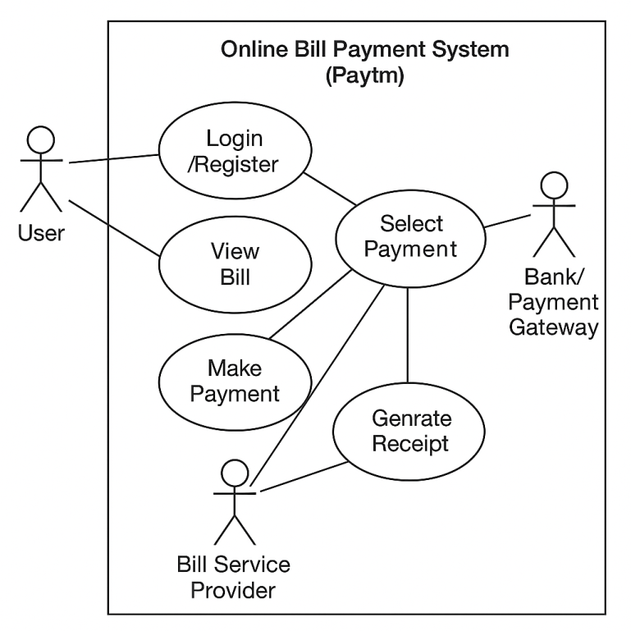**Draw Usecase on online bill payment system (paytm)**

**Answer:-**

* 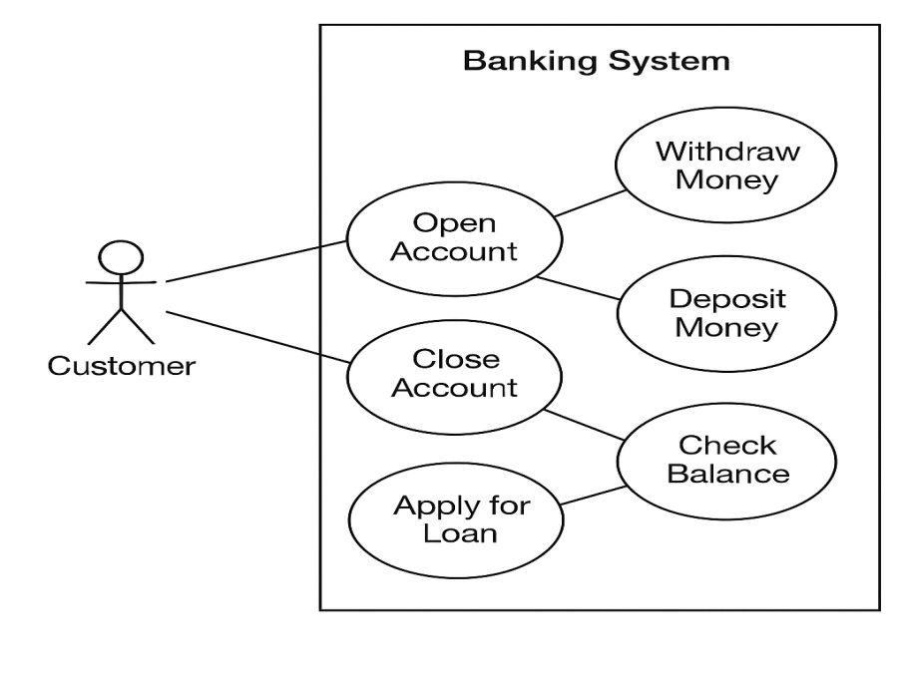**Draw Usecase on banking system for customer.**

**Answer:-**

* 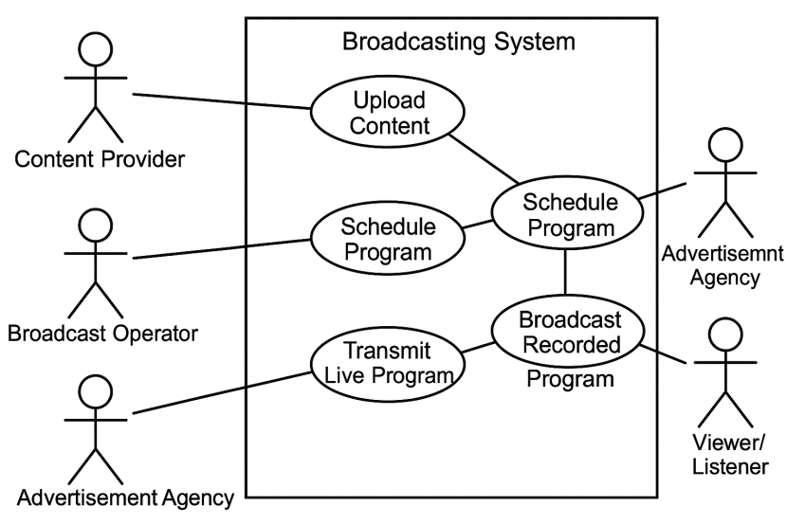 **Draw Usecase on broadcasting system.**

**Answer:-**

* **Write SDLC Phases with basic introduction.**

**Answer:- Phases of SDLC**

1.**Requirement Analysis**  
In this phase, developers and analysts gather complete information about user needs, business goals, and system requirements to prepare a clear Software Requirement Specification (SRS) document for the project.

2. **System Design**  
Here, the system architecture, database design, user interfaces, and module structures are planned. High‑level and low‑level designs are created to guide developers before the coding phase starts.

3. **Implementation (Coding)**  
Developers write actual source code using suitable programming languages as per design documents. The main aim is to convert design into a working system through clean, efficient, and structured code.

4. **Testing**  
Testers verify the developed software for errors, bugs, or missing requirements. Different testing methods are applied to ensure the software is reliable, secure, and meets the expected quality standards.

5. **Deployment**  
The tested software is installed and delivered to the client or live environment. Users can start using the system, and initial support or configuration is provided during this stage.

6. **Maintenance**  
After release, the software is monitored for errors or improvements. Updates, bug fixes, and new features are added to keep the system running smoothly and effectively for users.

* **Explain phases of the waterfall model.**

### **Answer:- Phases of the Waterfall Model**

1. **Requirement Analysis**  
   👉 In this phase, all user needs and system requirements are collected and documented in detail.  
   👉 Output: **Software Requirement Specification (SRS)**.

2 . **System Design**  
👉 Based on requirements, system architecture, database, interface, and module design are prepared.  
👉 Output: **High‑level and low‑level design documents**.

3. **Implementation (Coding)**  
👉 Developers write the program code as per the approved design.  
👉 Output: **Source code of the system**.

4. **Testing**  
👉 The developed software is tested thoroughly to find and fix bugs.  
👉 Output: **Error‑free, tested software**.

5. **Deployment**  
👉 The software is delivered and installed in the user’s environment for actual use.  
👉 Output: **Working software in real environment**.

6 . **Maintenance**  
👉 After delivery, the software is maintained, updated, and improved as per user feedback.  
👉 Output: **Enhanced and stable software over time**.

* **Write of phases spiral model.**

**Answer:-** **phases of the Spiral Model**:

1. **Planning Phase**
2. **Risk Analysis Phase**
3. **Engineering (Development & Testing) Phase**
4. **Evaluation (Customer Review) Phase**

* **Write agile manifesto principles**

**Answer:-**

| **No.** | **Agile Manifesto Principle** |
| --- | --- |
| 1 | Customer satisfaction through early and continuous delivery of valuable software. |
| 2 | Welcome changing requirements, even late in development. |
| 3 | Deliver working software frequently (weeks rather than months). |
| 4 | Business people and developers work together daily. |
| 5 | Build projects around motivated individuals; give them support and trust. |
| 6 | Face‑to‑face conversation is the best form of communication. |
| 7 | Working software is the primary measure of progress. |
| 8 | Promote sustainable development; maintain a constant pace. |
| 9 | Continuous attention to technical excellence and good design. |
| 10 | Simplicity—the art of maximizing the amount of work not done—is essential. |
| 11 | Best architectures, requirements, and designs emerge from self‑organizing teams. |
| 12 | Regularly reflect on how to become more effective and adjust accordingly. |

* **Explain working methodology of agile model and also write pros and cons.**

**Answer:-** Agile model works in **small iterative cycles (sprints)**.

* Requirements are divided into small features.
* Development and testing happen simultaneously in each iteration.
* After every sprint (usually 2–4 weeks), a working software version is delivered.
* Customer feedback is taken after each iteration and changes are easily accepted.
* Continuous communication and collaboration between developers, testers, and customers are maintained.
* The process continues until the final product is completed with all features.

### **Pros of Agile Model**

* Customer satisfaction with early and continuous delivery.
* Flexible to accommodate changing requirements.
* Regular feedback improves product quality.
* High transparency and collaboration.
* Faster delivery of working software.

### **Cons of Agile Model**

* ❌ Less documentation compared to traditional models.
* ❌ Requires experienced and skilled team members.
* ❌ Scope creep can occur due to continuous changes.
* ❌ Difficult to estimate exact cost and time initially.
* ❌ Requires constant involvement of the customer
* 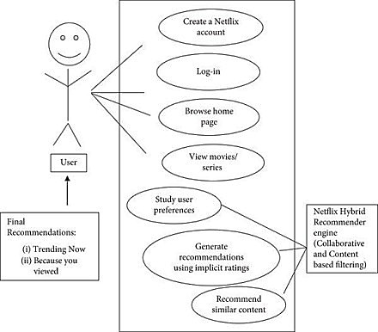**Draw usecase on OTT platform.**

**Answer**:-

* 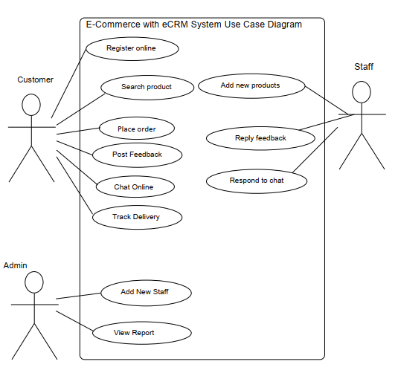**Draw usecase on E-commerce application .**

**Answer**:-

* 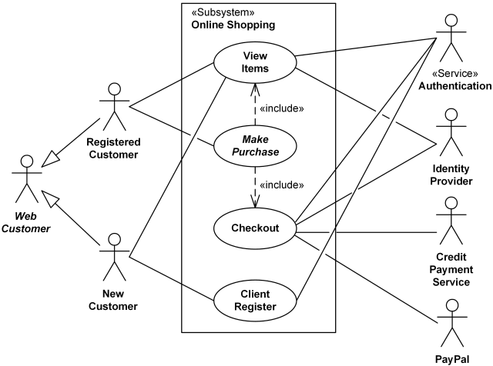Draw usecase on online shopping product using payment gateway

Answer:-